|  |  |  |  |
| --- | --- | --- | --- |
| Vysoká škola DTI | Portál VŠ | European Academy | University of New York in Prague - Czech Universities |  |

DTI University Dubnica nad Váhom

European Academy of Education, Prague

University of New York in Prague

Newton University



**INVITATION**  
to the 1st International Scientific Conference  
**Human Potential Management 2025:  
Perspectives in Corporate and Institutional Practice**

|  |  |  |
| --- | --- | --- |
| **Conference date:** November 26, 2025 (Wednesday), 9:30 AM  **Venue:** online | | C:\Users\bockova\Downloads\frame.png |
| C:\Users\bockova\Downloads\ChatGPT Image 31. 8. 2025 13_46_22.png | The conference Human Potential Management 2025: Perspectives in Corporate and Institutional Practice is intended for doctoral students and early-career researchers focusing on studies in human resource management, talent development, and modern approaches to work. The aim of the event is to connect the academic sphere with corporate and public practice, and to stimulate discussion on current trends, challenges, and opportunities for the effective utilization of human potential. Participants will have the opportunity to present their research findings, exchange experiences, and establish professional contacts. The conference focuses on new approaches to employee development, the digital transformation of work, innovative forms of education, and sustainable leadership. The discussions will contribute to identifying practical solutions that support the adaptability of organizations and individuals in the dynamic environment of 2025 and beyond. | |

**Conference sections:**

|  |  |
| --- | --- |
|  | 1. ****E****ducation and Human Potential Development   This section focuses on innovative approaches to education, competency development, and lifelong learning. Discussions will address trends in educational technologies, personalized learning, and talent development programs. |
|  | 1. Digital Transformation and the Future of Work   This section explores how digitalization, automation, and artificial intelligence are reshaping the nature of work. It will focus on new work models, flexibility, and the need for workforce adaptation to rapidly changing environments. |
|  | 1. Sustainable Leadership and Organizational Culture   This section is dedicated to values, ethics, and the social responsibility of leaders. It will highlight the importance of creating a sustainable organizational culture that fosters collaboration, inclusion, and the long-term prosperity of organizations. |
|  | 1. Innovation in Talent Management and Work Processes   The aim of this section is to present new approaches to attracting, retaining, and motivating talent. Discussions will cover innovative methods of team management, agile processes, and strategies to enhance employee performance and satisfaction. |

|  |  |
| --- | --- |
| **Participation in the conference requires completing the application no later than November 1, 2025.** | C:\Users\bockova\Downloads\fialovy_qr_s_formularem.png |

### **Conference Language and Paper Submission**

The working languages of the conference are Slovak, Czech, and English. Papers may be submitted in Slovak, Czech, or English.

Selected English-language papers submitted to **Section 1: Education and Human Potential Development** will, after a positive peer-review process, be published in the journal ACTA EDUCATIONIS GENERALIS (<https://www.dti.sk/p/19-vedecky-casopis>).

English-language papers submitted to **Sections 2–4** will, after a positive peer-review process, be published in the journals Scientia et Societas (<https://sets.cz/index.php/ojs>) or Acta Sting (<https://www.sting.cz/acta-sting>).

Papers in Slovak or Czech will be published in the peer-reviewed proceedings Socialium, issued in the Czech Republic.

### **Structure and Formatting of the Scientific Paper**

A scientific paper should follow the recommended structure:

* Title of the paper
* Author’s/Authors’ full name(s), affiliation, e-mail address
* Abstract (approx. 150–200 words)
* Keywords (3–5 terms)
* Introduction
* Objective and methodology
* Results and discussion
* Conclusion
* References (APA style)

The recommended length of the paper is **10–15 standard pages**.

The paper must be submitted **by November 30, 2025**, by uploading it to the conference team in MS Teams, folder Files – Papers.

### **Formatting and Acceptance**

After a positive peer-review process and acceptance, authors will be asked to revise their paper according to the official template of the respective journal or proceedings in which the text will be published.

**Scientific Committee**

Dr.h.c. prof. PhDr. PaedDr. Ing. Daniel Lajčin, PhD., DBA, LL.M, DTI University

Dr.h.c. prof. PhDr. PaedDr. Gabriela Gabrhelová, PhD., DBA, LL.M, DTI University

prof. PaedDr. Tomáš Lengyelfalusy, PhD., DTI University

### [PhDr. David Anthony Procházka, Ph.D., MBA, MSc](https://www.iniciativa-snih.cz/phdr-david-anthony-prochazka-mba-msc/), University of New York in Prague

## doc. Mgr. Emil Velinov, Ph.D., [RISEBA University of Applied Sciences](https://www.linkedin.com/company/15096149/?lipi=urn%3Ali%3Apage%3Ad_flagship3_profile_view_base%3BuY1B8qA%2FR8aYRe4ZjEukRw%3D%3D)

PhDr. Pavel Bartoš, LL.M., DBA, European Academy of Education, Prague

Ing. Daniela Maťovčíková, Ph.D., School of Management / City University of Seattle in Bratislava

dr hab. Roman Gawrych, prof. WSSE, Założyciel Wyższej Szkoły Społeczno-Ekonomicznej w Gdańsku

dr inż. Zygmunt Mietlewski, prof. WSSE, Dyrektor Instytutu Rozwoju i Doskonalenia Procesu Kształcenia Studentów i Kadr, Wyższa Szkoła Społeczno-Ekonomiczna w Gdańsku

dr. inž. Waldemar Kunz, Uniwersytet Pomorski w Słupsku

**Conference Chair**

doc. PaedDr. Mgr. Ing. Kateřina Bočková, Ph.D., MBA, DTI University

**Organizing Committee**

Mgr. Katarína Pagáčová, DTI University

Andreas Skraba, MBA, DTI University

Mgr. Andrea Uríčková, DTI University

PhDr. Juraj Lovásik, MPH, DTI University

PhDr. Mgr. Michal Krajčírovič, DTI University

Ing. et Ing. Pavel Semerád, Ph.D., MBA, Vysoká škola STING

Ing. Julie Holendová, Newton University

Ing. Petr Zimčík, Ph.D., Newton University

[doc. Ing. Ondřej Dvouletý, Ph.D., MSc, University of New York in Prague](https://kpo.vse.cz/o-katedre/seznameni-s-katedrou/lide/ondrej-dvoulety/)

Mgr. Ing. Vojtěch Zika, Ph.D., University of New York in Prague

Ing. Václav Fiala CSc., LL.M.  European Academy of Education, Prague

Ing. David Zejda, Ph.D.  European Academy of Education, Prague

Mgr. Štefan Tkačik, DTI University

Bianca Triebel, MBA, DTI University

PhDr. Marek Hlásny, Comenius University in Bratislava

Mgr. Ivana Hužovičová, DTI University

PhDr. David Mazák, Ed.D., MBA, DTI University

**CONFERENCE PROGRAM**

**9:30–9:45**

Registration of participants

**9:45–10:00**

**Opening**

Assoc. Prof. PaedDr. Mgr. Ing. Kateřina Bočková, Ph.D., MBA, DTI University

### **Keynote Lectures**

### **10:00–10:20**

### PhDr. David Anthony Procházka, Ph.D., MBA, MSc, University of New York in Prague

### Evidence-based management

### **10:20–10:40**

### Assoc. Prof. Mgr. Emil Velinov, Ph.D., RISEBA University of Applied Sciences

### HR Trends in Global Automotive Firms

### **10:40–11:00**

### PhDr. Pavel Bartoš, LL.M., DBA, European Academy of Education, Prague

### Hybrid Forms of Work and Teaching Using A.I. Tools

### **11:00–11:20**

Ing. Daniela Maťovčíková, Ph.D., School of Management / City University of Seattle in Bratislava

Comparative Analysis of Forms of Employee Training: Benefits and Limits

### **11:20–12:30**

### Lunch break

### **12:30–15:30**

### Section sessions

### **15:30–16:00**

### Conference conclusions

**Contact**

**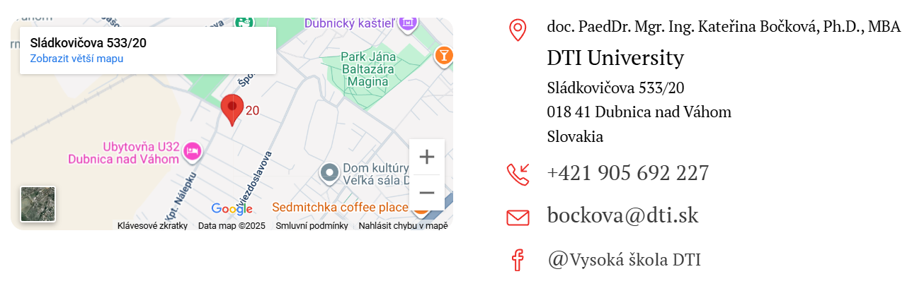**

**Conference website**

